5th Grade Language Arts Syllabus
Mrs. Taunya Kolbinger
2017-18

Taunya Kolbinger, Room 210
Taunya.Kolbinger@mpls.k12.mn.us
http://mrskolbinger.weebly.com
Field: 668-3640
Welcome to Field!
My name is Taunya Kolbinger and I will be your Language Arts teacher this year. This is my tenth year teaching, and my fifth year at Field. I am excited to begin our literary adventures together. Please read and sign this syllabus and include any questions, so that I can be sure all information has been read and understood. I look forward to getting to know you and working together throughout the year!
Overview
5th grade Language Arts at Field will focus on developing our skills as readers, writers, speakers, and critical thinkers. Each of our units is structured around an essential question. Through reading, writing, speaking, and listening, we will tackle that question and become stronger learners.

 | Unit | Essential Question | Final Project
1 | Tall Tales | How do tall tales reveal something about human character? | Tall Tale Story
2 | Locomotion | How does poetry give an author voice? | Poetry Writing/ Opinion Essay
3 | Tuck Everlasting* | How do we make difficult choices? | Persuasive Project
4 | Number the Stars* | Is it our duty as humans to help others in need? | Realistic Fiction Research Paper

* Books subject to change

Reading
Daily reading is the foundation of our 5th grade year. Students will read choice books along with whole-class novels, short stories, nonfiction, and poetry. Throughout the year students will track, reflect on, and share their reading minutes online. Students are expected to bring their choice book with them to class each day. Students are also required to read at least 100 minutes a week at home and log minutes online weekly at http://www.scholastic.com/ups/campaigns/src-2014 (this can be found on my webpage under “websites”). The amount of reading time at home will increase as the year goes on. Our yearly goal is to read 60 hours out of class.
Writing
Writing is a significant piece of every unit, from daily tasks to final projects. Throughout the year we will explore fiction, drama, poetry, informational, and multi-genre writing. We will take time to learn and practice grammatical and organizational skills to become stronger writers and communicators. During each unit students will participate in the writing process, from brainstorming and drafting to peer conferencing and revising. Writing is a part of our daily routine in Language Arts, and students are expected to come to class everyday with their class journals prepared to write.

Vocabulary and Grammar
We will start first semester with weekly grammar lessons and assignments. Students are always expected to use their best grammar. Greek and Latin roots and words related to our units of study will be our second semester focus. We will use the study of Greek and Latin roots to help us make sense of word patterns and meaning.
Homework
Students are expected to read 100 minutes a week (this is in addition to our in-class reading time), and log minutes weekly online. Students will also complete a weekly grammar study, assigned on Friday which is due the following Friday. Other projects and assignments will be given as homework as they come up. Please check the classroom website for due dates and assignments.
Grading and Evaluation
We will use Learning Targets developed from MN Common Core Standards to guide our daily lessons and formative assessments. I will continue piloting a new grade scale called Standards-Based Grading (SBG). I believe this is the best way to grade students and their understanding and achievement of the English Language Arts standards. Check out my website for more information on SBG.
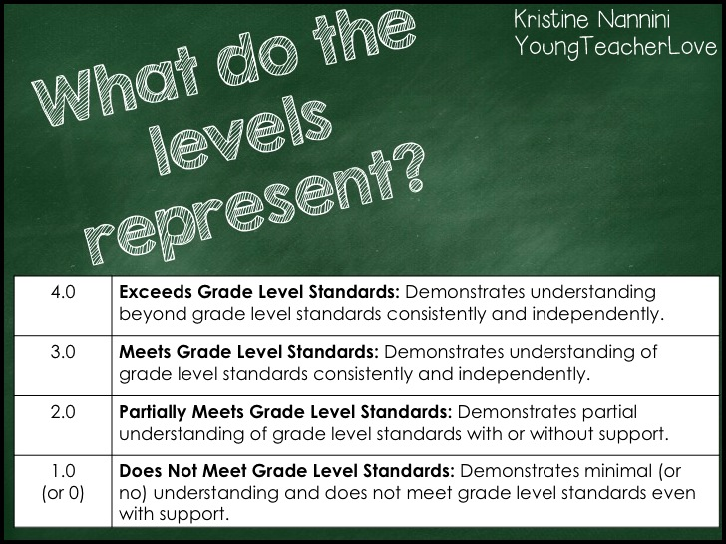

ELA Grade Scale
Symbol | Value | Description
4 | 88-100% | Exceeds Standards
3 | 63-87% | Meets Standards
2 | 38-62% | Partially Meets Standards
1 | 0-25% | Does Not Meet Standards
N/E or N/A | n/a | No Evidence

It is each student’s responsibility to make up any missing work. Work will not be accepted after each quarter ends.

Parent Involvement
It is my hope that parents be actively involved in their child’s education at Field Middle School and in the 5th grade Language Arts classroom. Please use the online Parent Portal to check in with your student’s progress, and do not hesitate to contact me (e-mail is best) to discuss your child’s areas for growth and areas of success. You can help me by being sure your child follows weekly homework expectations and by communicating any concerns or questions. I look forward to conferencing with you and working together to ensure that your child has the best education possible.
We are constantly adding to our classroom library, so if you would like to donate any young adult and age-appropriate texts, our hungry readers would be more than grateful!
Required Materials
- 1 Notebook (green)
- 1 Folder (green)
- Pencil or pen (at least 2 each day)
- Student Planner
- Choice Book
Optional Materials
Classroom novels (2nd semester novels subject to change) for easy marking of the text.
- - - - - - - - - - - CUT OR TEAR HERE AND RETURN PORTION BELOW - - - - - - - - - - - - -
5th Grade Language Arts Mrs. Kolbinger
Please sign and return by Friday, August 28th
  - We have read and understand the 5th Grade Language Arts expectations.
  - As a student I agree to follow the preceding guidelines and all other instructions given in class.
  - As a parent I agree to support my student as a learner and to contact Mrs. Kolbinger should any questions or concerns arise.

Student Signature: ____________________________________________ Class Hour: _____________

Parent/Guardian Name(s): _______________________________________________________________________________

Parent/Guardian Signature(s): _______________________________________________________________________________

Parent/Guardian Email(s): ________________________________________________________________

Please check what applies to you:
I do ____________ do not ________________ have a computer at home.
I do ____________ do not ________________ have Internet at home.

Questions:

